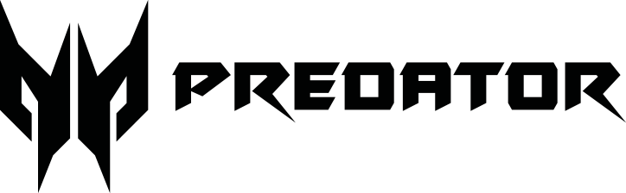
Data Sheet

Predator Rift Go 331

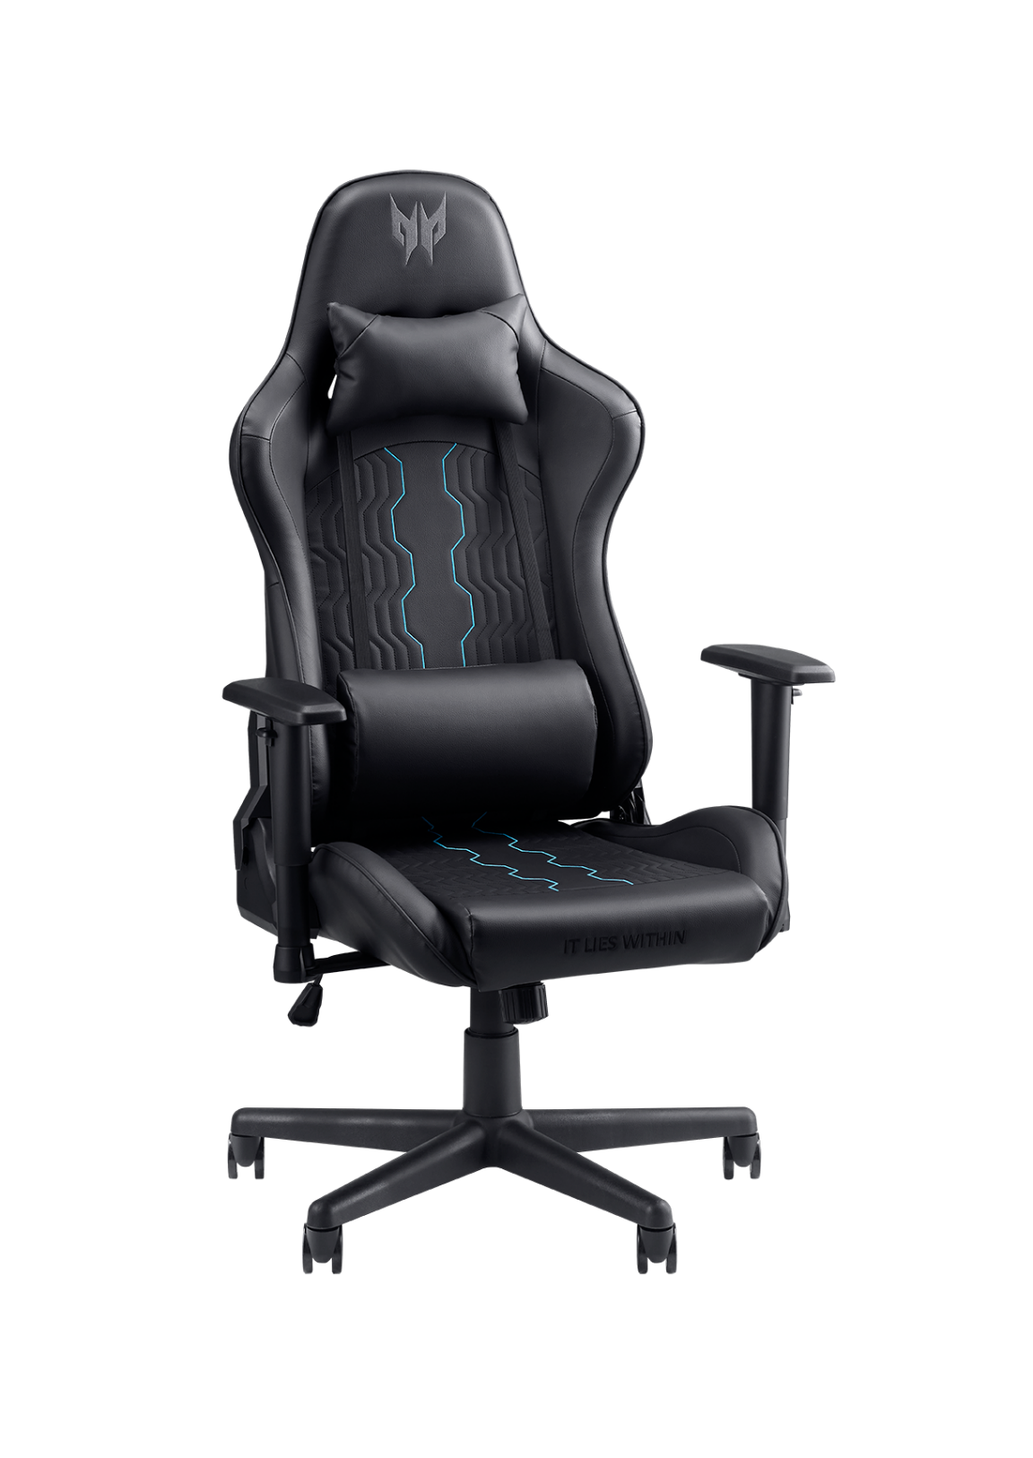

Rift Go Gaming Chair
Engineered for immersive play, this gaming chair delivers ergonomic support, sleek Predator styling, and the durability to keep you in command match after match.

LEAN BACK IN TOTAL COMFORT
Tilt up to 160° to match your playstyle—whether you're locked in or laid back. A padded headrest, lumbar cushion, and 7cm foam offer lasting comfort and ergonomic support.
ESSENTIAL ARM SUPPORT
The streamlined 1D armrest keeps your elbows supported where it counts. Adjust your height, stabilize your aim, and stay focused through every round.
BUILT TO LAST, DESIGNED TO PERFORM
Constructed with a durable metal frame, Class 3 gas lift, and wide nylon base, this chair offers reliable strength, smooth adjustability, and long-term comfort.

Data Sheet | Predator Rift Go 331
Specifications
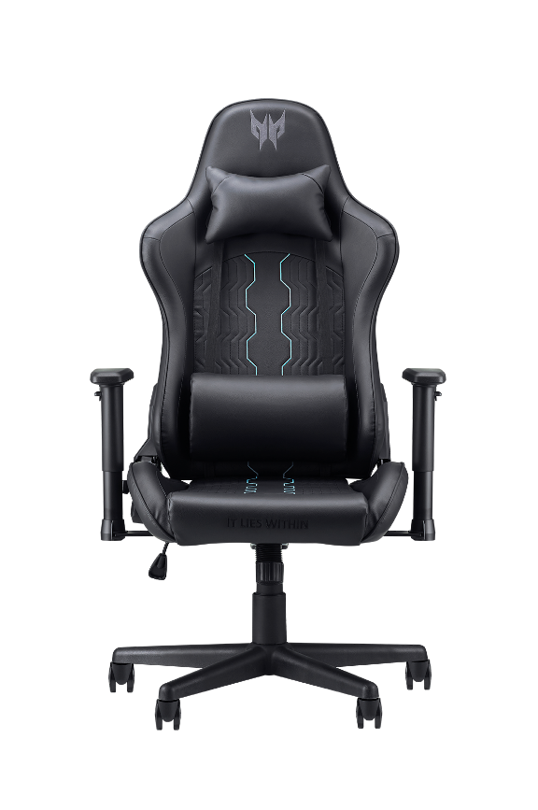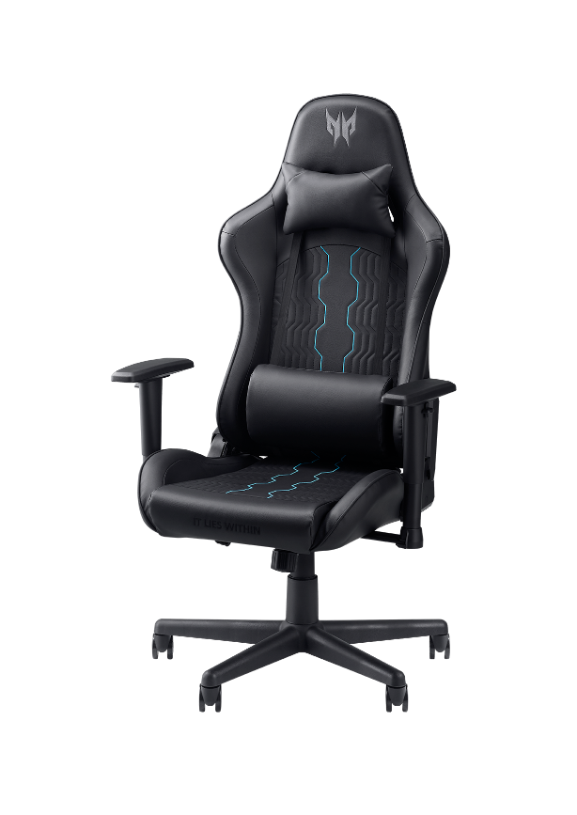

Predator Rift Go 331

Dimension | 70 x 65 x 130cm
Weight | 19kg
Support | Head & Back pillows
Material | 70mm molded foam with high end PU cover
Features
  Backrest tilt adjustable from 90° to 160°
  1D Arms with PU pads
  Class 3 100mm gas lift
  Steel structure
  350mm metal base

© Copyright 2025 Acer Inc.

